Week 2:

Step 1: I create a topology in GNS3 by joining 4 hosts and 1 switch. I configured each hosts using text editor and change IP address manually. I tried to ping from host 1 to host 3 and it was successfully. I assigned individual IP address for each host like 192.168.10.10 and 192.168.10.20 and so on.
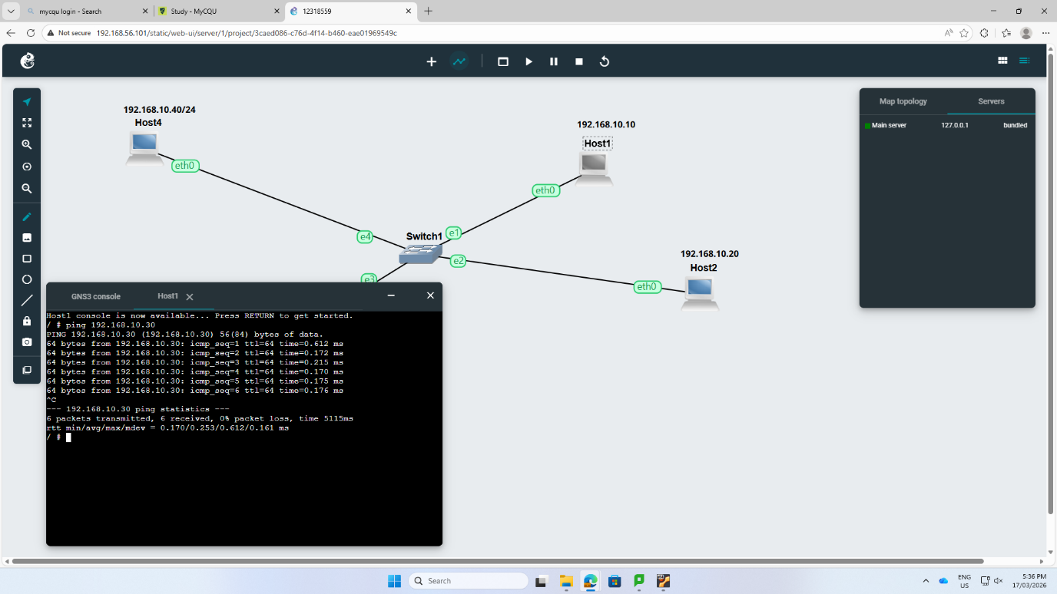

Step 2: Ping command was used to examine the connection through each host. Different types of commands were used to test the connectivity such as ping -c was used to see count affected and -I was used to examine the interval and so on.

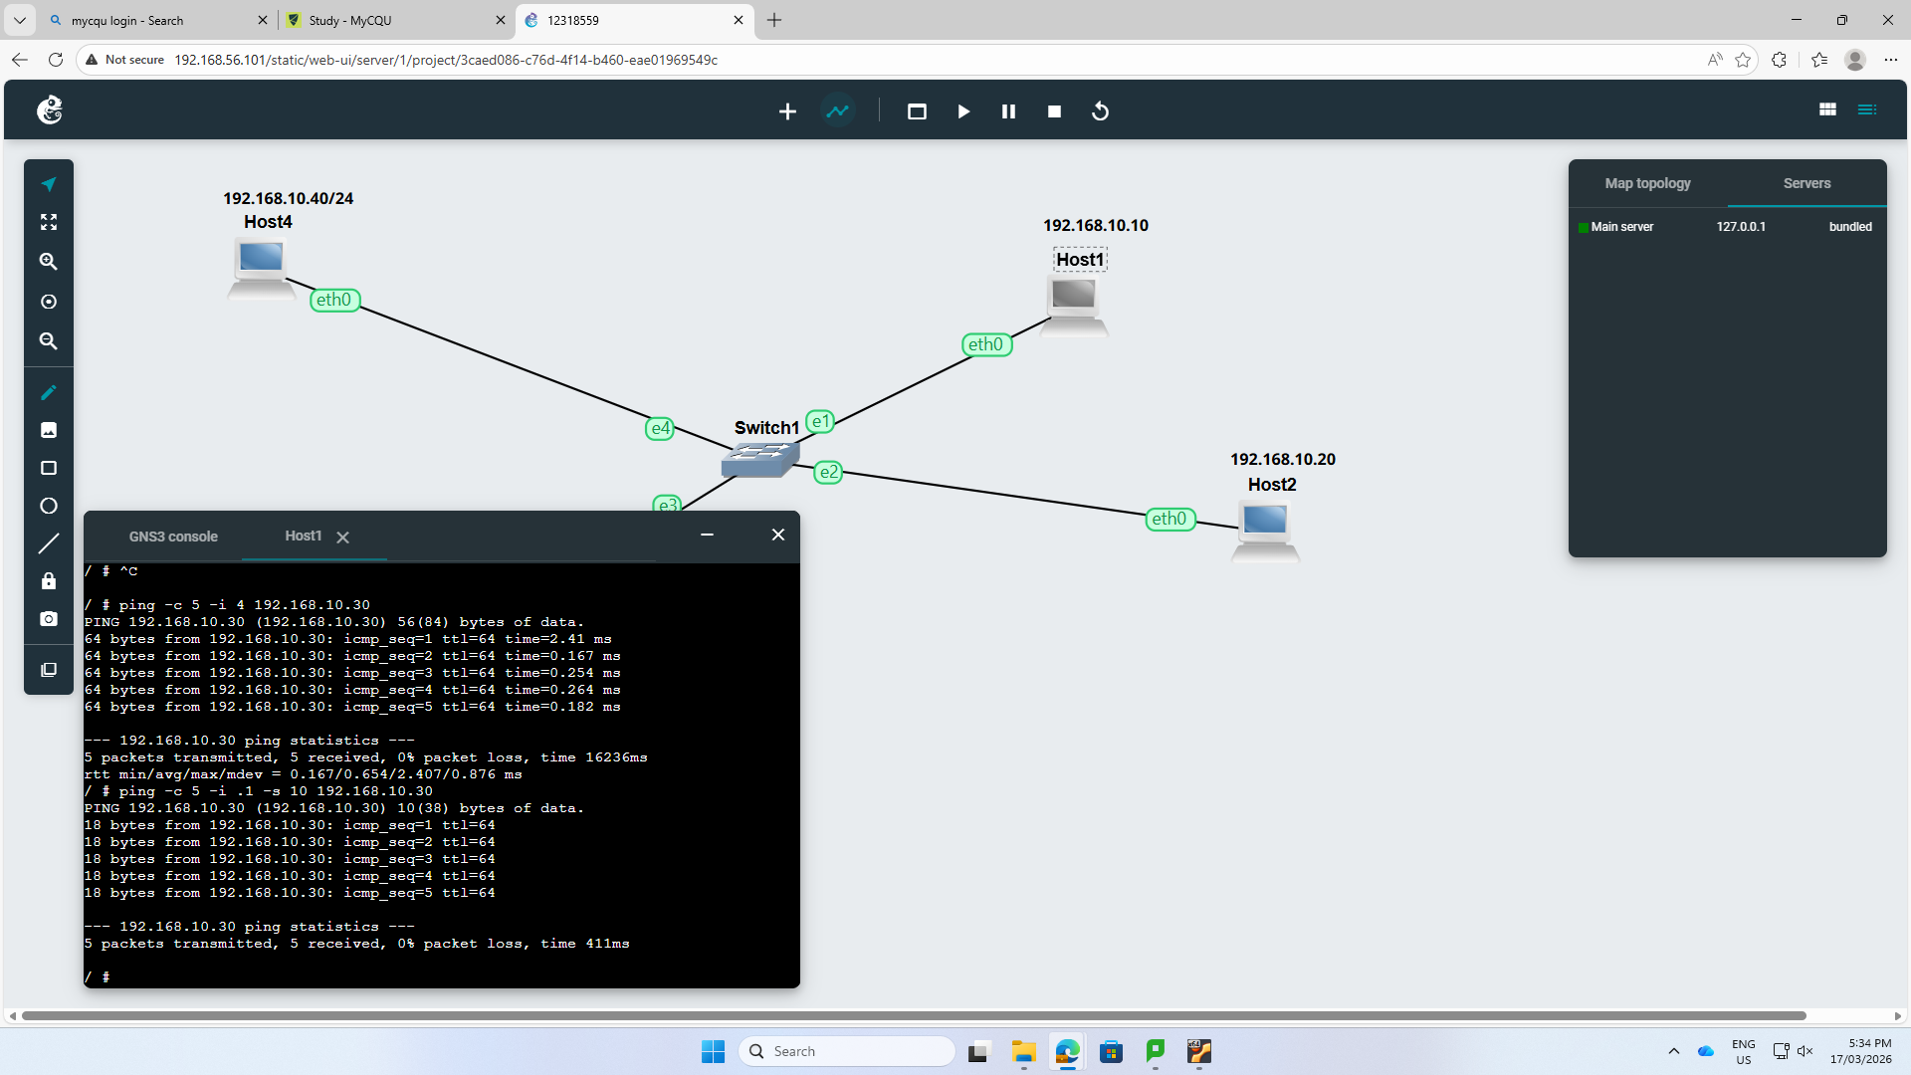
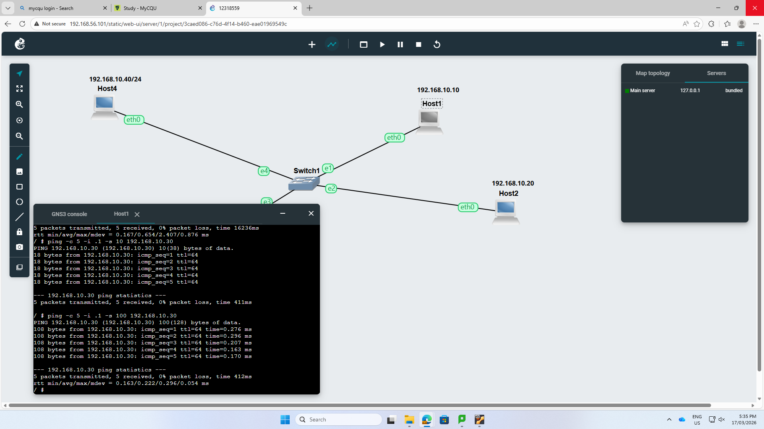

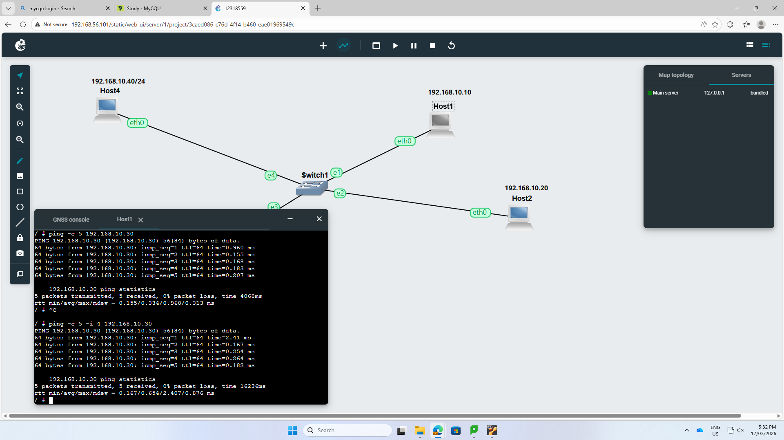

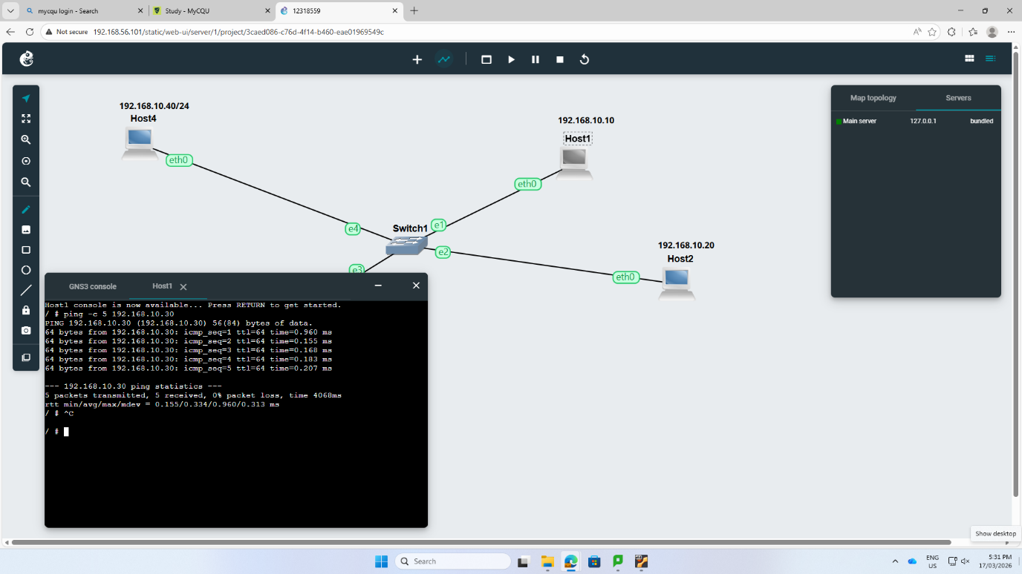
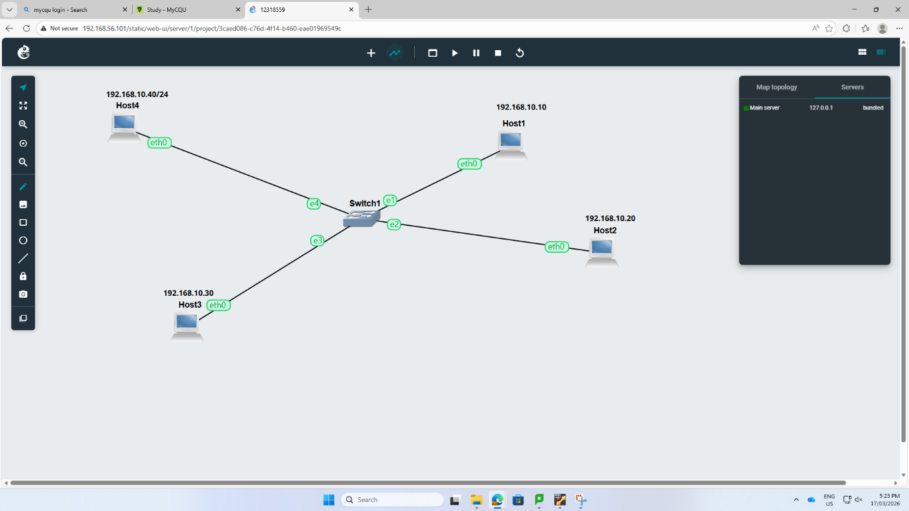

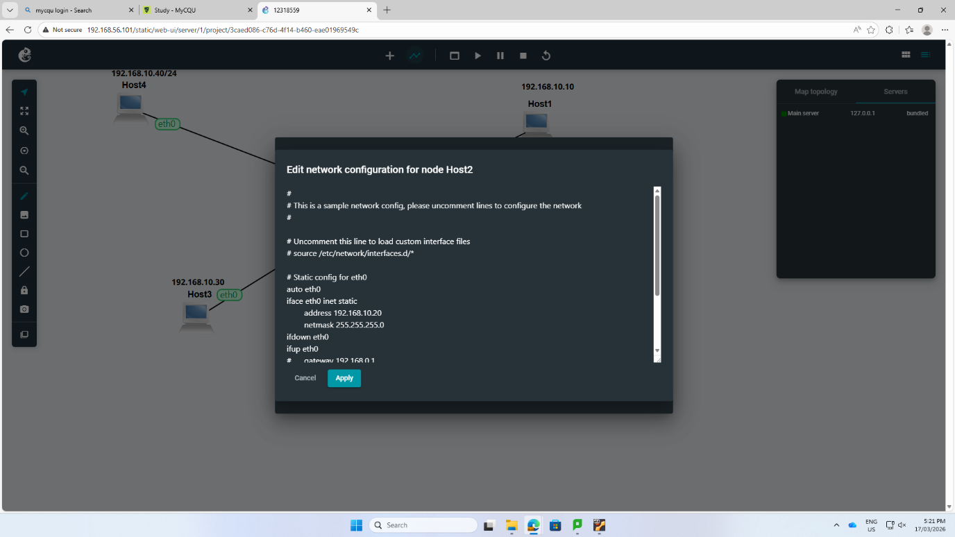
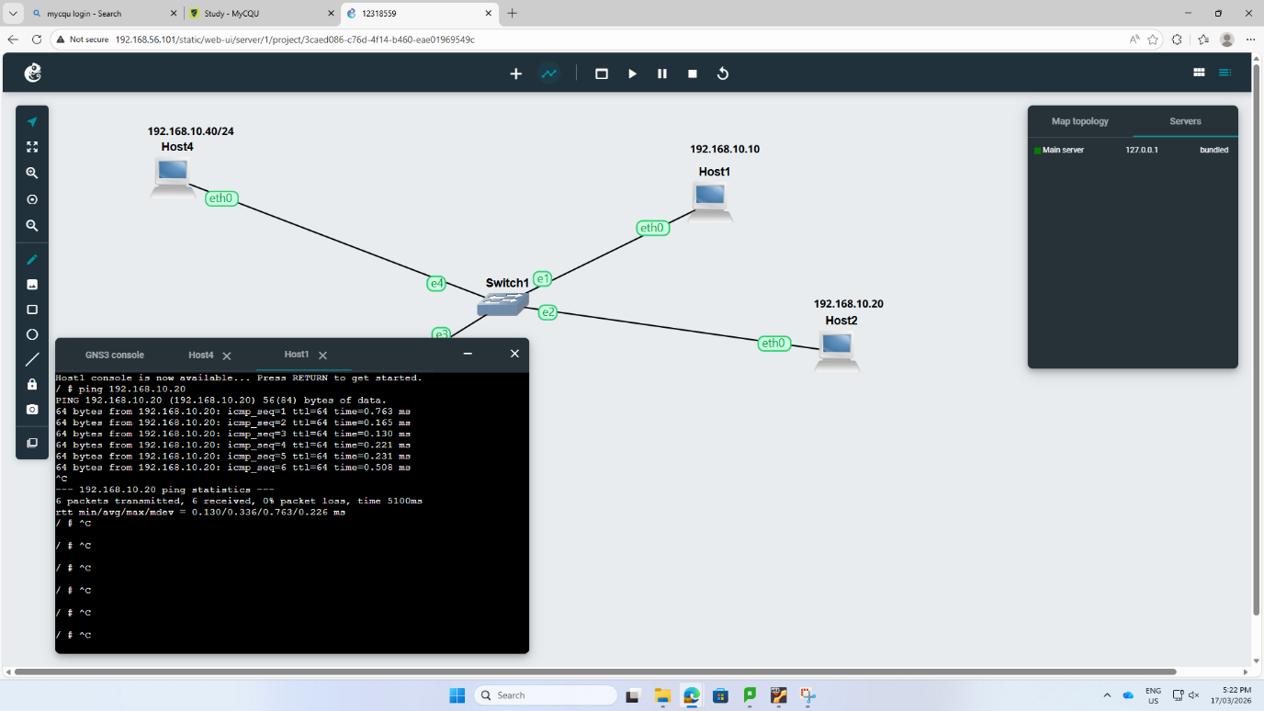

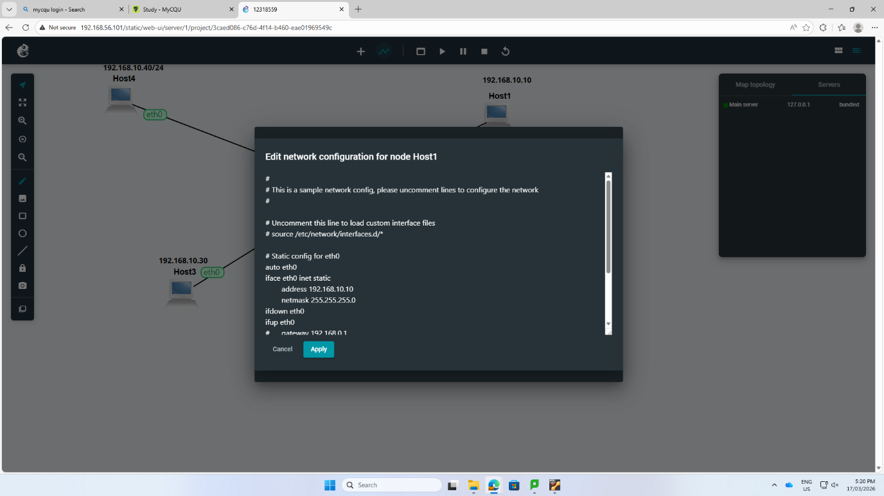
Step 3: It was done before testing the ping command. IP add show command was used to know the new IP address of each host.
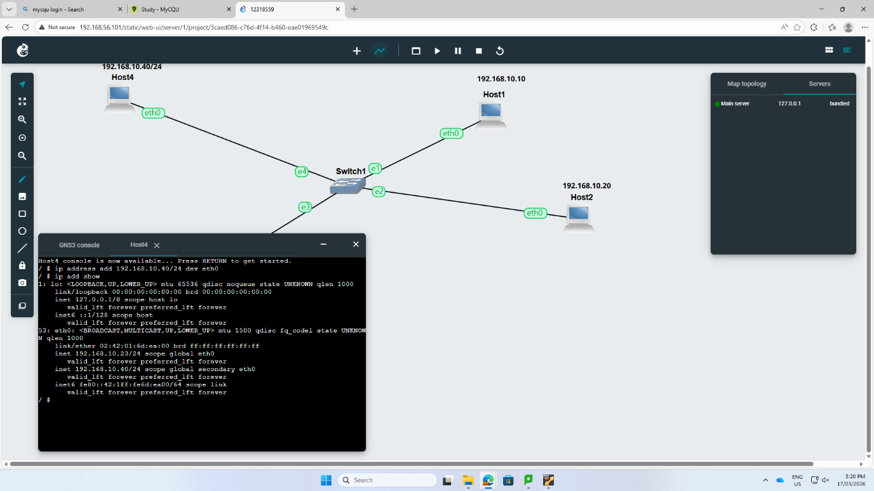

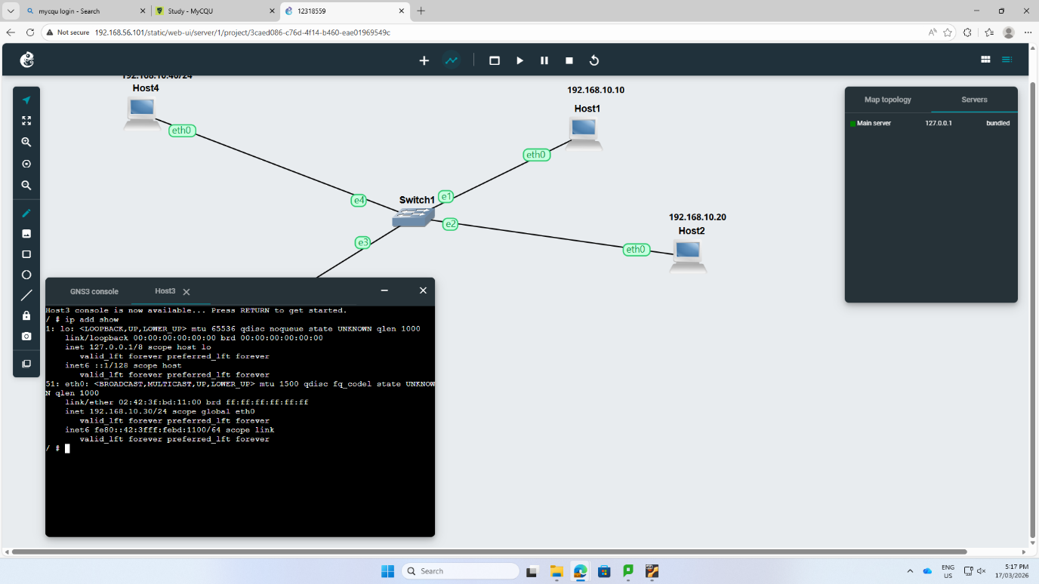
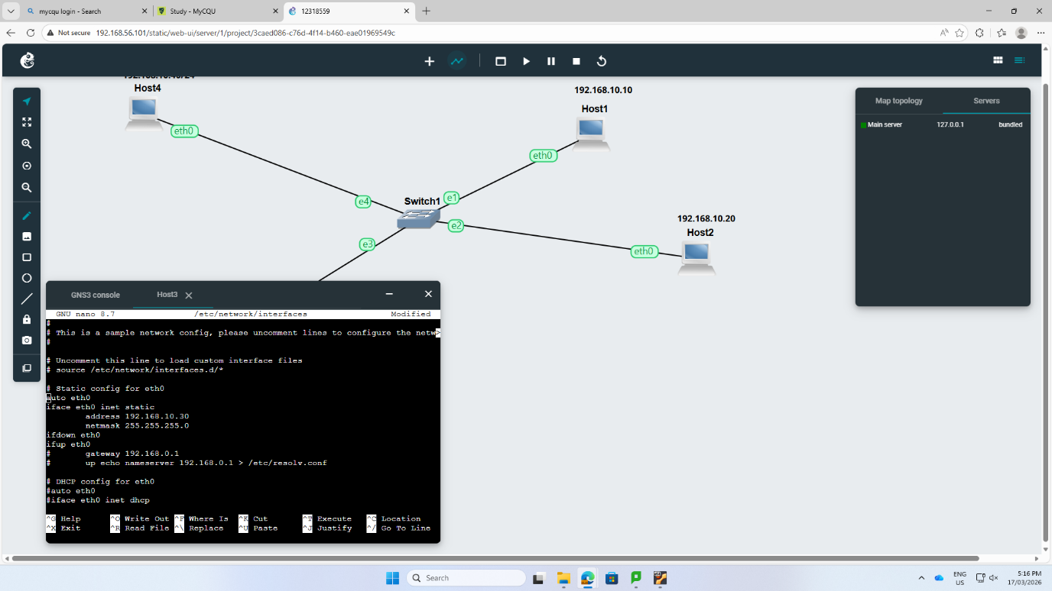


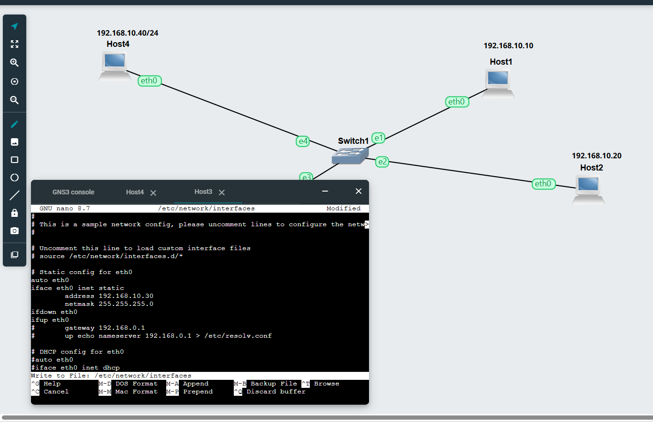
Step 4: The pinging was successful as we can see in above screenshots 0% packet loss, as it confirms that the hosts can communicate with each other.

Reflection:
In week 2, I learned about different kind of pinging command. Firstly, I learnt about the basic steps of putting a functional local network. Setting IP address through manual process, I got to know the process of how devices know their IP address in themselves. The successful pinging proves that my way of addressing and setting the IP address was very correct. I got to know the function of each command such as ping -c and -I indicates time return and time interval. I also got realize that even the small mistake in setting up the IP address can stop hosts from communicating.

